Hi! My name is Sheliza, a final year Journalism and Creative Writing student, a School Community Organiser for the School of Social Sciences, Humanities and Education (SHE) and a UH Sustainability Advocate.

Last Tuesday, our School of SHE had its thrift event after weeks of collecting donations of clothes and books from students.

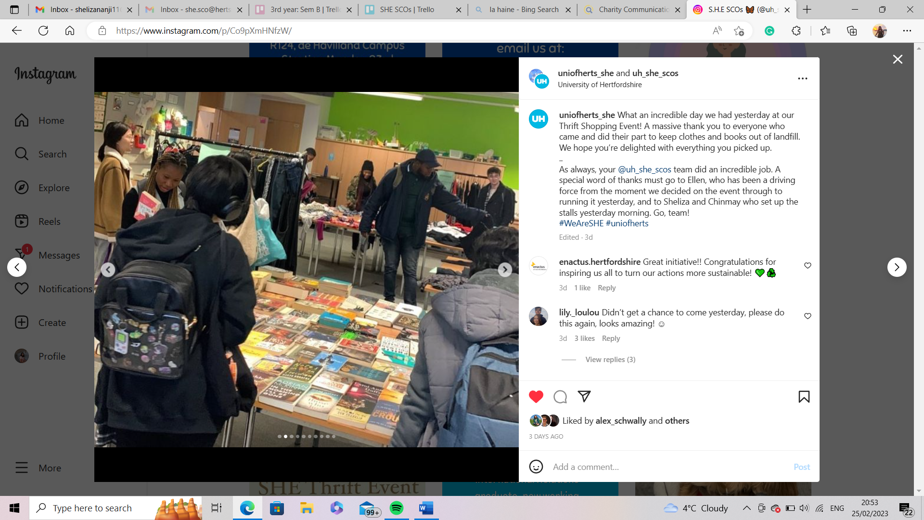

My fellow SCO, Ellen, along with the support of our Associate Dean of Student Experience, Ciara, worked since the beginning of Semester B to organise an event promoting sustainable practises. This idea eventually resulted in a swap shop, where people donate items and take items for free. This helps the environment by keeping items like clothes and books out of landfills.

Ellen and the rest of us promoted this all-over social media, on campus and through Canvas to try and get donations from students. We received hundreds of clothes and books from SHE students and staff who wanted to help! Last Tuesday, we set up in R115 on the de Havilland Campus, beginning our thrift event at 2 and finishing at 5. Dozens of students dropped by picking up to 5 items each, with more students also donating throughout the day.

The event was a huge success with photos and videos being shared across the main university channels. More than anything, we raised awareness about sustainable practises, introducing students to simple ways they can help the environment.

*“It was great to see so many people from our school come along and swap some clothes, books, and other miscellaneous items! We had so many donations during the weeks before the event and then even some on the day! It was an absolutely brilliant turn out - better than we have ever expected, with some people going away with a whole new wardrobe!*

*We have lots of items still left over so watch this space (and our Instagram) - we might have something to announce soon!” –* **Ellen**

Follow us on Instagram: @uh_she_scos

