- Log in to your student record

- From the menu on the right-hand side select Submit Request
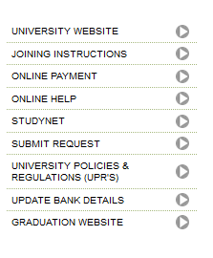
- Select relevant academic session from the available list

- Select a Request type (Exceptional Circumstances)

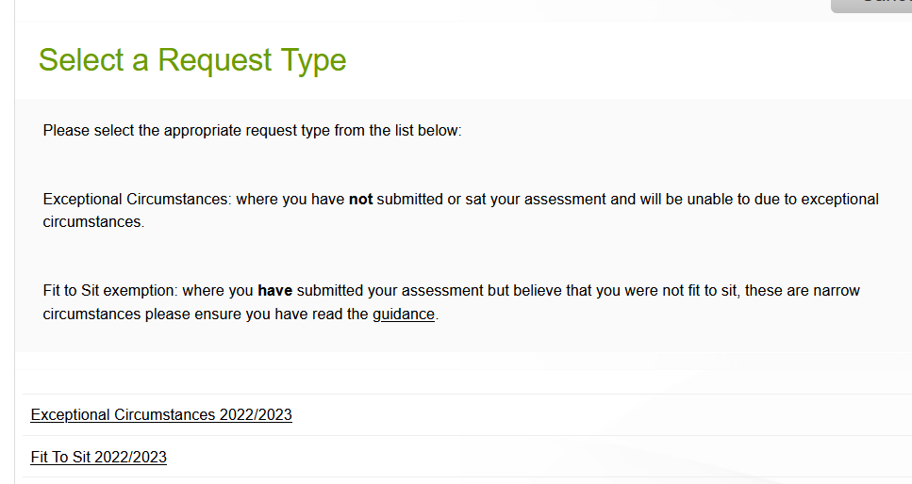

- Confirm your details are correct and click next

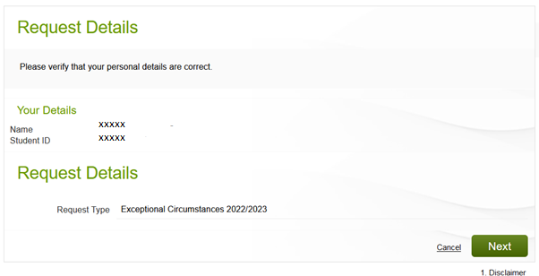

- Select the course instance the serious adverse circumstances are related to and click next

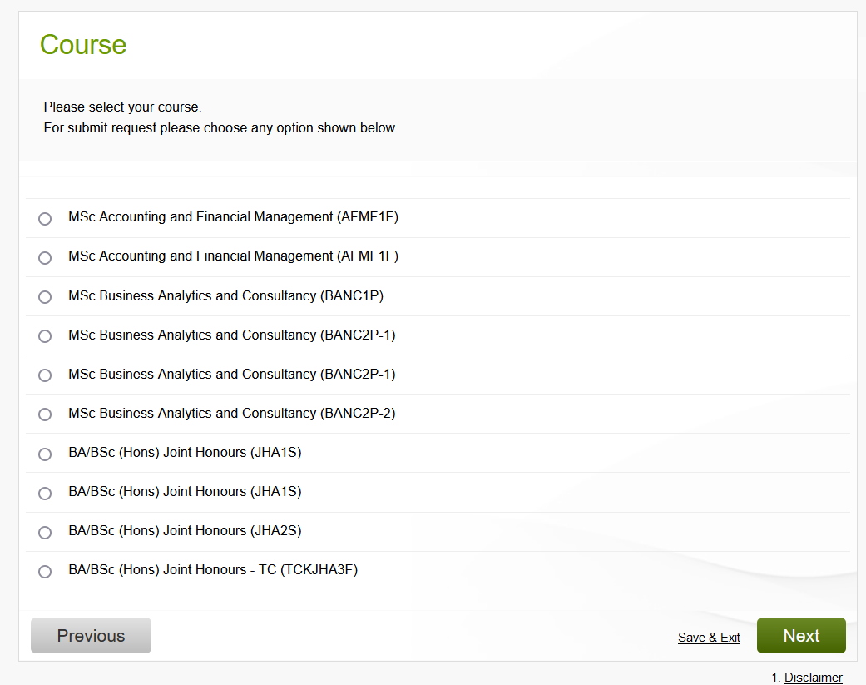

- Please ensure you read the guidance

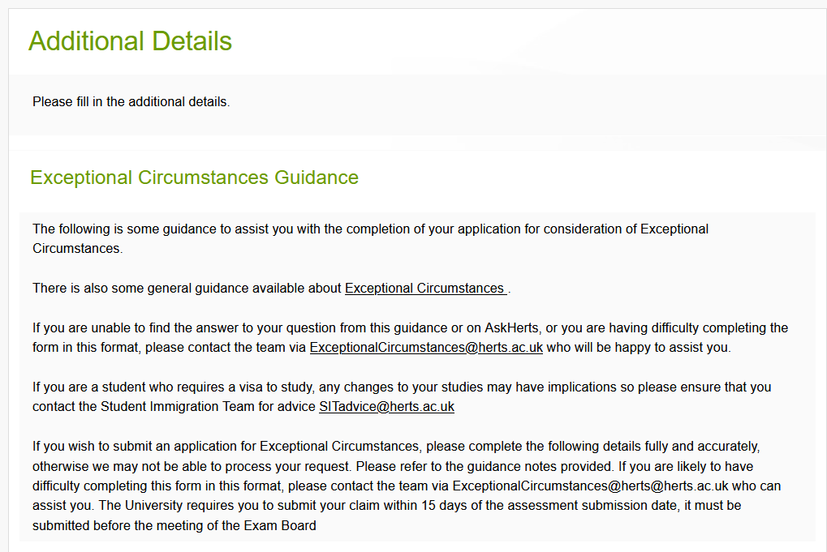

- Tick all the required fields
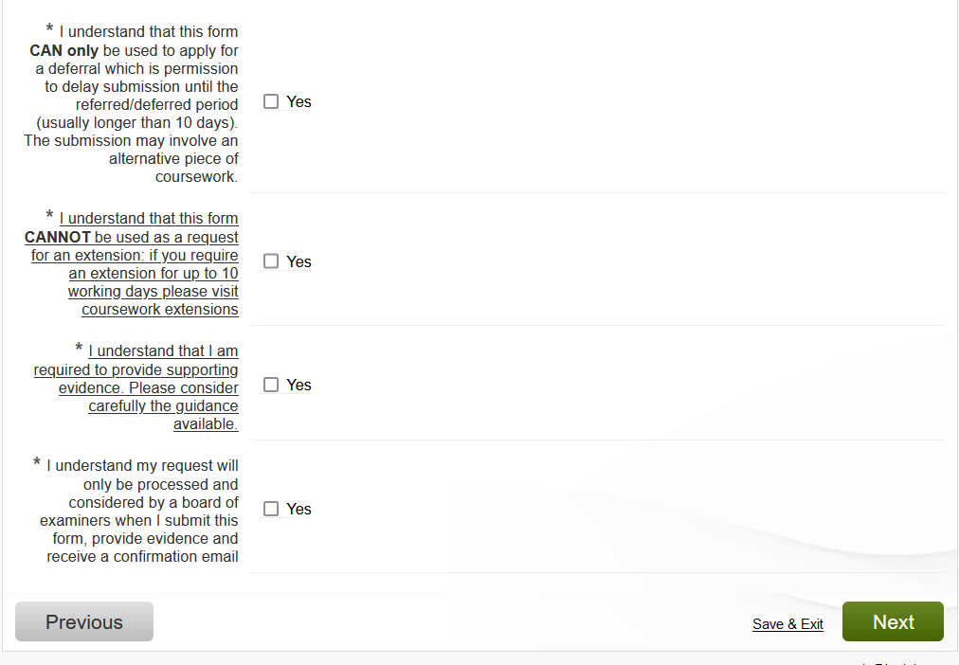

- Fill in the Additional Details.

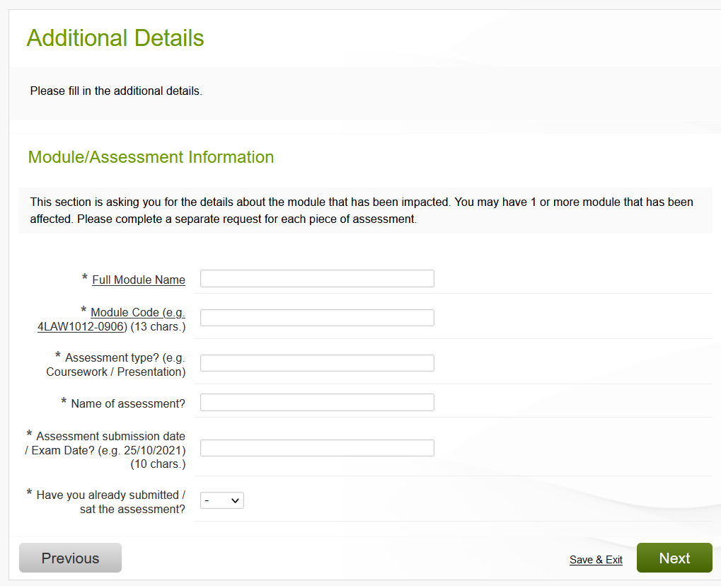
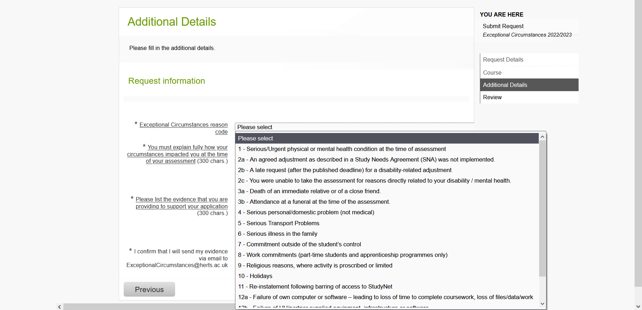
- Once you have submitted your online form, you will need to email your evidence to exceptionalcircumstances@herts.ac.uk

- You will then see a new tab on your online student record
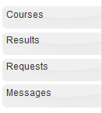

- This will allow you to see the progress of your requests.

- To view the details of the request, click Submit Request

- You will need to submit a separate request for each assessment effected.

