
Is your Employer asking for a Term Letter?

Follow these steps to access the information the university provides—
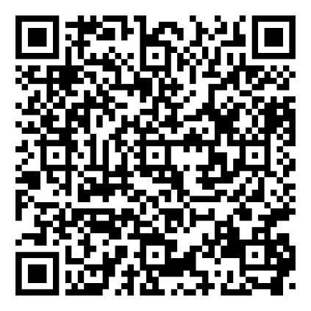
- Request your Student Letter—
Scan here for the link or click here
You should receive an email within half an hour with a link to the PDF document that you can print.
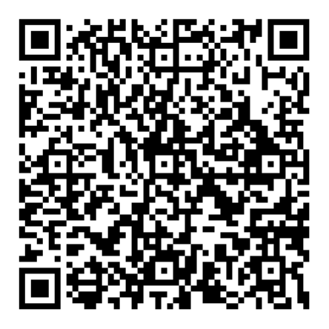
- Print the information for university term and semester dates—
Scan here for the PDF document for Academic Year 2024-2025 or click here
Page 1 explains in narrative form and Page 2 explains in graphic form by week
You can print Pages 1 and 2
- Access your course study pattern—
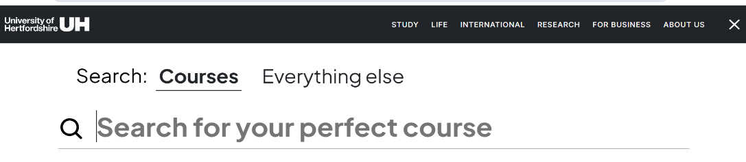
Search for your course on the main university website: https://www.herts.ac.uk/

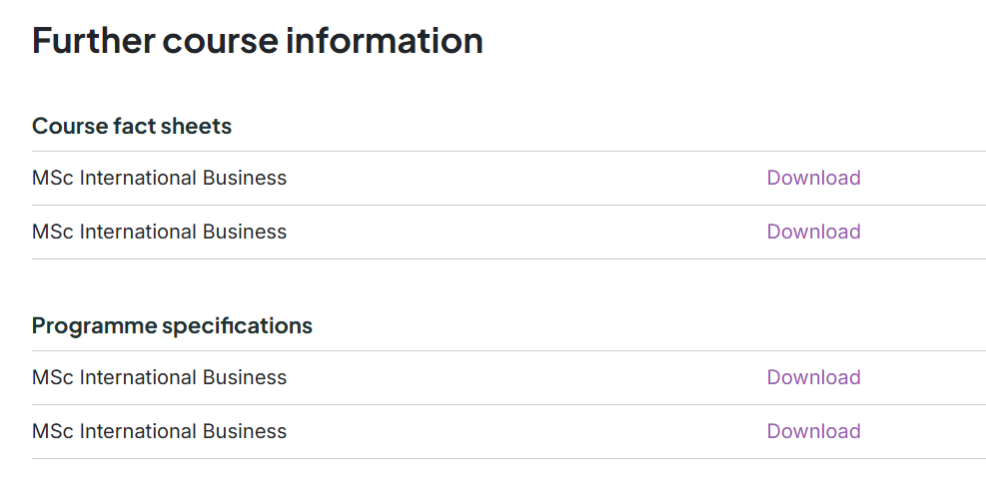
Scroll down the page to “Further course information” and open the “Programme specification”

Scroll to Section D for “Programme structure”

Look for your course (Full-time, with Placement or with Advanced Research), the correct semester entry point (September or January) and the study pattern of semesters, and any vacation periods listed. If there are no specific vacation periods listed, look at the semesters to see when you are studying or not.
