Frequently Asked Questions about Your Award

When will my Award result be published 2
Will my Award change? 3
Can I attend a graduation ceremony? 3
How can I view my GPA results? 3

When will my Award result be published
Awards are conferred by a Programme Board of Examiners. Your Award will be published once your Student Record has been updated to reflect the decision of the Board. It can be viewed in the results section (see example below).
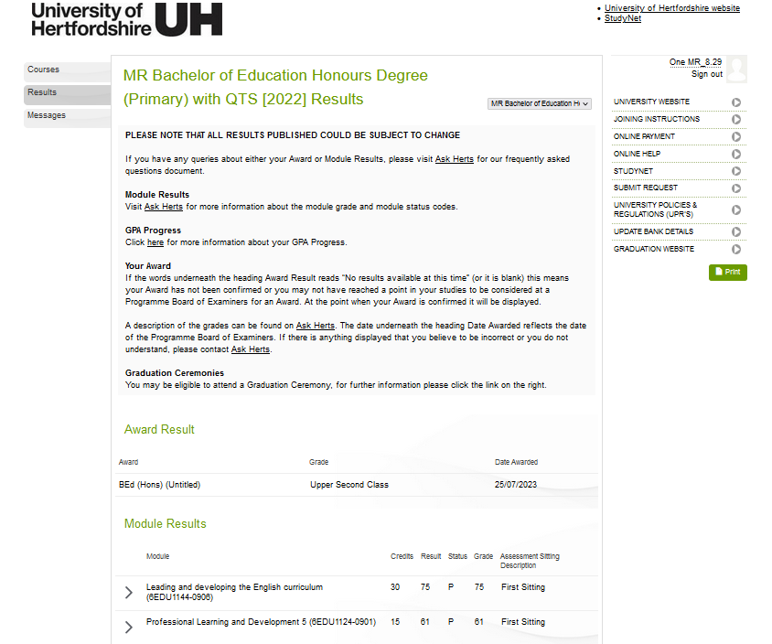
If the message “No results available at this time” is displayed under the heading Award Result this means your Award has not yet been confirmed (or you have not yet reached a point in your studies to be considered for an Award).
In some circumstances the Programme Board of Examiners may give you the option of accepting an “interim” award rather than returning to study to achieve the final award. If the Board decide this is appropriate (based on your performance) your result will not be published on your Student Record and you will be contacted with the details and asked to indicate (by a particular date) whether you wish to accept the interim award or whether you will opt to return to study.

Your Award will be published once you confirm acceptance of it, or once the deadline has passed should you not respond.

Will my Award change?
The Award published to you has been conferred by a Programme Board of Examiners, after considering your overall performance. The Board will not normally change your Award unless there are grounds under the appropriate University Policies and Regulations (AS12 appendix 1 section 5.4).

Can I attend a graduation ceremony?
You can find out if you are eligible to register to attend a graduation ceremony on-line via http://www.herts.ac.uk/graduation.
To ensure you don't lose your opportunity to attend, you must meet all the deadlines set out on the website.

How can I view my GPA results?
Your GPA (Grade Point Average) will be displayed in the “GPA Progress” section at the end of each level or year you are studying for your undergraduate degree (Please note postgraduate students are not eligible for a GPA).
For each module you study, a “Grade Point” will be displayed alongside the numeric grade, using a standard scale. The GPA is then calculated from the average of the Grade Points at the end of each stage of your studies and then again upon completion of your undergraduate programme, to a University of Hertfordshire approved methodology. Please note that if you have any module grades with the historic assessment status of P(40) or P(50) the grade point for these modules used in the GPA calculation will be capped to 1.75 or 2.5 respectively in line with UH regulations at the time those assessment statuses were awarded.
Please also note that you will not receive a Grade Point for any assessment that is marked on a Pass/Fail basis. More information on GPA can be found on Ask Herts. (link to ask herts)

